Cutting Edge: How Autonomous Robots Are Shaping the Future of Surgery

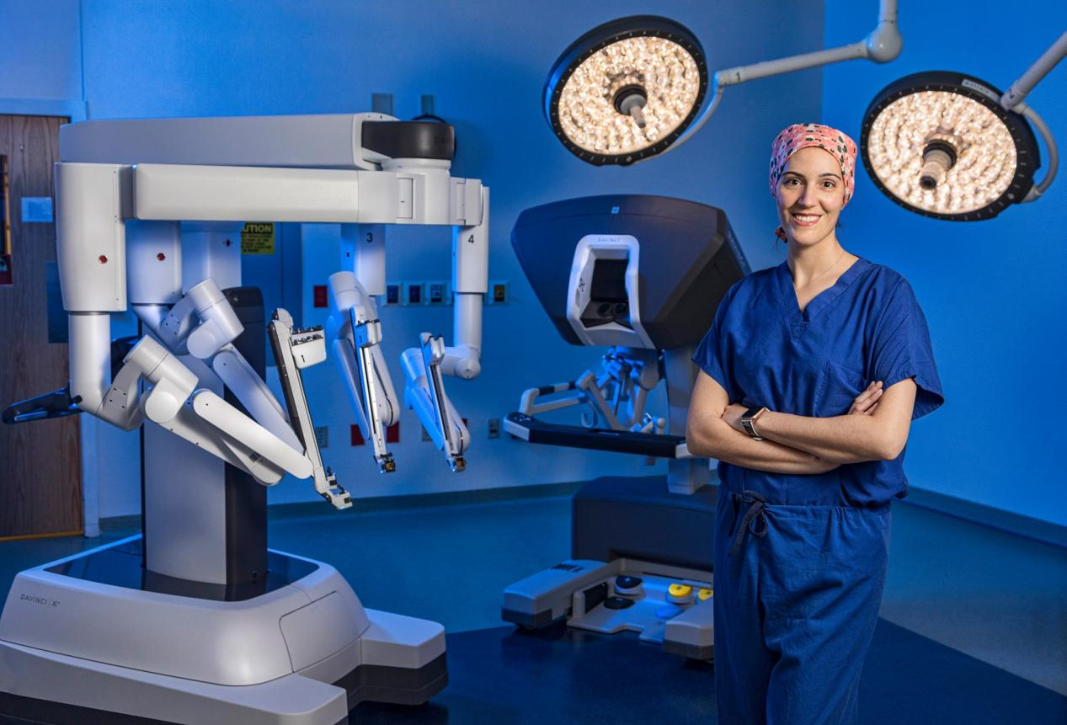

Figure 1. The Future Operating Room

When you lean on an operating table, anesthesiologist counts down from 10. And when it gets to 7, you see two figures moving over you. These are a robot and the operating surgeon. Surgical robots today are primarily used to assist surgeons in minimally invasive procedures, offering increased precision, dexterity, and control. With rapid advancements in artificial intelligence and robotics, fully autonomous surgical robots are likely to replace human surgeons in specific procedures within the next decade, offering greater precision, consistency, and efficiency in routine surgeries. As AI algorithms advance and hardware becomes more sophisticated, the operating room is undergoing a transformation, with robots increasingly taking on complex surgical tasks independently. This evolution will make us human feel twice as safe when lying on the operating table.

Table 1 Different types of surgical robots

|  |  |  |  |
| --- | --- | --- | --- |
| **Surgical Robot Systems** | **Type of Surgery** | **Success Rate (%)** | **Task It Excels At** |
| Da Vinci Surgical System | Prostatectomy | 90-98% | minimally invasive prostate surgeries;  lower rates of complications;  faster recovery times |
| Mako Robotic-Arm Assisted | Knee and Hip Replacement | 97-99% | orthopedic surgeries;  better outcomes in joint replacement |
| CorPath GRX | Percutaneous Coronary Angioplasty | 96-98% | clear blocked arteries in heart surgeries;  precise catheter placement;  improved procedure outcomes |
| ROSA Robotic System | Neurological Surgery | 93-95% | brain and spinal surgeries;  highly accurate targeting in complex neurological procedures |
| Versius | General and Colorectal Surgery | 92-96% | Compact design with modular arms;  minimally invasive surgeries |

Fully autonomous surgical robots promise to eliminate the variability inherent in human performance. Even the most skilled surgeons can experience fatigue, stress, or hand tremors, which can lead to errors during delicate operations. Autonomous systems, on the other hand, can perform with consistent precision for extended periods, regardless of external factors. They can also be programmed to make micromovements beyond the capabilities of the human hand, resulting in higher accuracy in procedures that demand meticulous detail. This would be especially beneficial in microsurgeries or procedures that require navigating narrow spaces, reducing complications and improving patient outcomes. In addition, autonomous robots are more likely to perform surgeries with minimally invasive techniques, reducing trauma to the body. These procedures lead to smaller incisions, less blood loss, and fewer postoperative complications such as infections. Over time, as fully autonomous systems perfect these techniques, the overall burden on healthcare institutions could decrease, freeing up resources for other medical needs and allowing hospitals to treat more patients efficiently.

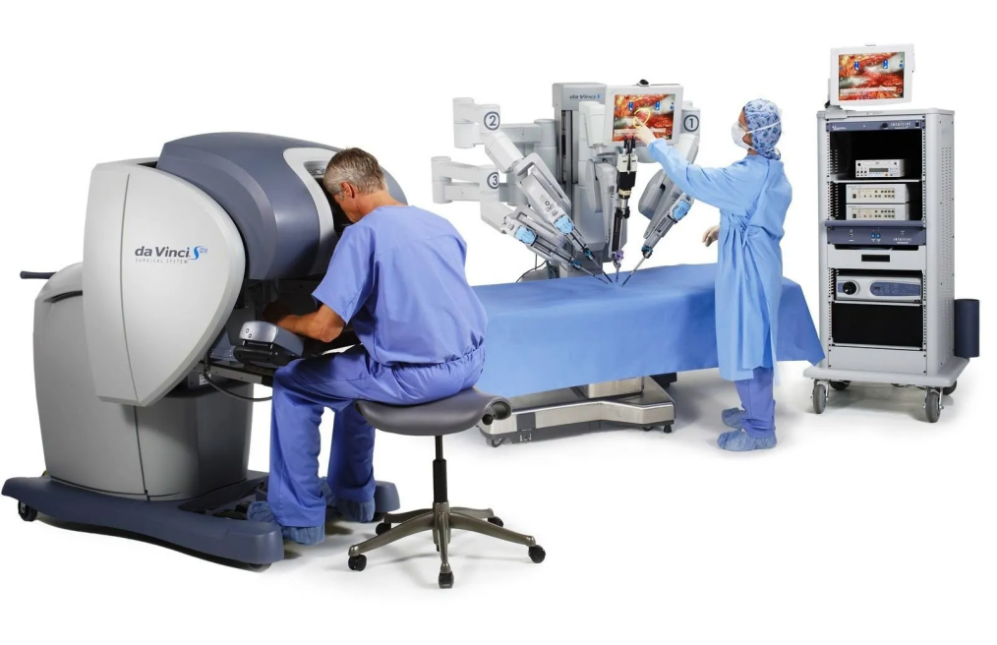

Figure 2 Da Vinci robotic surgical system

Today’s surgical robots, like the Da Vinci system, are primarily used to assist human surgeons, excelling in tasks that demand precision such as stabilizing instruments and minimizing hand tremors. These machines are equipped with multi-arm configurations and intuitive controls, making them indispensable for minimally invasive surgeries. However, while they reduce human error, they still require human surgeons to guide and control them. We are at the stage where robots augment, but do not replace, the role of the surgeon. The potential for surgical robots to achieve full autonomy is no longer science fiction—it’s a reality on the horizon.

One of the major bottlenecks preventing fully autonomous surgical robots from becoming mainstream is the complexity of surgical decision-making. Surgeons must make real-time judgment calls, adapting to unexpected complications or variations in patient anatomy. While robots can currently follow pre-programmed movements and execute tasks with precision, they still struggle with these unpredictable variables. Similarly, autonomous vehicles faced similar hurdles in their development—navigating unpredictable environments, reacting to sudden changes, and ensuring passenger safety. Initially, self-driving technology was limited to ideal conditions with well-defined roads, but with advances in machine learning, sensor technologies, and real-time data processing[1], autonomous vehicles are now capable of handling complex scenarios such as sudden pedestrian crossings or unpredictable weather. In the same way, we can expect surgical robots to improve their decision-making capabilities by integrating AI that learns from vast amounts of surgical data, adapting to anomalies in real-time. Just as the self-driving car’s sensors and algorithms allow it to navigate dynamic environments, surgical robots will be able to adjust mid-procedure, responding to unexpected complications with the precision and speed that surpass human capabilities. With continuous improvements in AI, sensor accuracy, and real-time feedback, it is only a matter of time before the bottlenecks of autonomous surgery are resolved, much like the strides we’ve seen in autonomous vehicles.

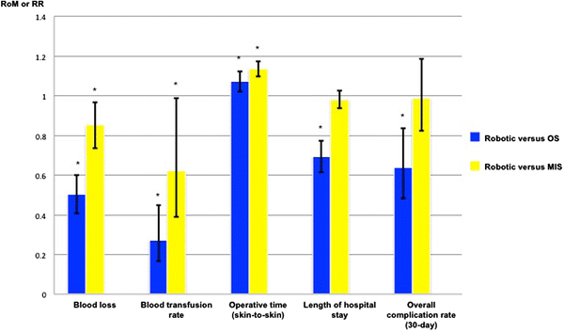

Figure 3 Pooled proportional change in perioperative outcomes for robotic versus open surgery and robotic versus minimally invasive surgery

Leading companies like Intuitive Surgical, Stryker, and Zimmer Biomet are at the forefront of this innovation, working to overcome the technical and ethical barriers that stand in the way of full automation. These companies are not just focused on creating robots that replicate human abilities but are developing platforms that could surpass human performance in routine and highly specific surgeries. For example, researchers at Johns Hopkins University have developed the Smart Tissue Autonomous Robot (STAR)[2], a system capable of performing soft tissue surgeries with remarkable precision, such as suturing, often outperforming human surgeons in terms of consistency and accuracy. Meanwhile, at MIT, researchers are developing robotic systems that can use real-time data from imaging technologies like MRI and CT scans to adjust surgical approaches dynamically, enabling more personalized and adaptive surgeries.

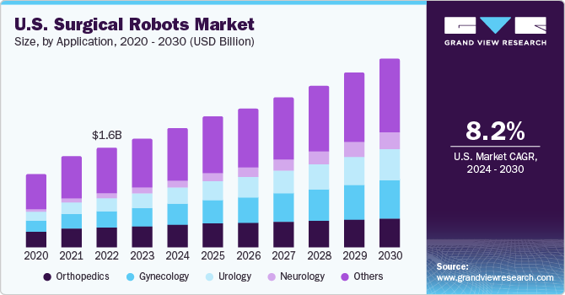

Figure 4 U.S. Surgical Robots Market

In addition to hardware advancements, breakthroughs in AI and machine learning are critical in pushing the boundaries of what surgical robots can achieve. For instance, research into reinforcement learning allows robots to refine their techniques through trial and error, mimicking the way human surgeons perfect their skills over time. Furthermore, AI-driven predictive analytics are being explored to anticipate complications during surgery before they arise, enhancing decision-making capabilities. Enhanced imaging technologies, such as hyperspectral imaging and intraoperative fluorescence-guided surgery, are also being integrated into robotic platforms to provide real-time, high-resolution data about tissues and blood flow, allowing robots to make more informed surgical decisions. With these innovations and real-time decision-making capabilities, the vision of fully autonomous surgical robots handling complex operations may become a reality in the next decade.

1. Purwanto, E. (2024). A Bibliometric Analysis of Trends and Collaborations in Autonomous Driving Research (2002-2024). Mechatron. Intell Transp. Syst., 3(2), 85-112. <https://doi.org/10.56578/mits030202>
2. Johns Hopkins University. (2022, January 26). Robot performs keyhole surgery on pig’s soft tissue. The Hub. <https://hub.jhu.edu/2022/01/26/star-robot-performs-intestinal-surgery/>